Mid-Term Project Planning Document
Shakila Shrestha
CIT 312

The Project Topic:
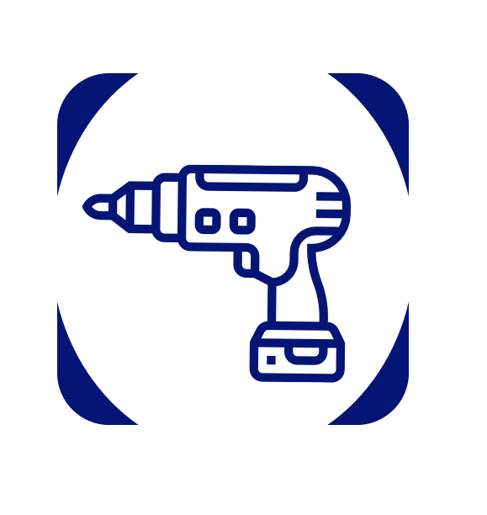
Siddhaleka Aluminium & Steel Udhog
Construction Solutions Website
This web application presents a company portfolio showcasing services related to aluminum fabrication, steel fabrication, and toughened glass installations. The website allows users to explore services, view design examples, and submit a service request form.
The goal of this project is to present construction and architectural services in a clean, modern web interface that demonstrates good web development techniques.
Project Topic | Construction Solutions Services
Landing Page Content Page#1 | Home Page  Header: “Modern Fabrication Services”, centered  Subheading: “High-Quality Aluminum, Steel & Glass Solutions for Your Projects”  Project Images  Quick Short Form  Nav: Logo | Nav Bar  Navigation bar: Home | Services | Request Services | Contact
Content Page #2 | Service Page  Combined all services under three main categories: Aluminum, Steel, Glass  Each category has 2–3 example flip cards (front = image + service name, back = short description)  Nav: Logo | Nav Bar  Navigation bar: Home | Services | Request Services | Contact
Content Page #3 | Nav: Logo | Nav Bar  Navigation bar: Home | Services | Request Services | Contact  Request Service  Simple form:  - Name  - Email  - Phone no.  - Location  - Service Type dropdown, checkmark, radiocheck (Aluminum/Steel/Glass)  - Project Description  - Comments
Content Page #4 | Contact Page  Nav: Logo | Nav Bar  Navigation bar: Home | Services | Request Services | Contact  Company Info  Social Media Links  Get help question and forms  - Simple form:  - Name  - Comments
Responsiveness | Landing page images resize at smaller breakpoints  Flex containers switch between row and column flex-direction  Hamburger menu for mobile  Form and flip cards fully responsive
Professional Finish | Favicon representing company brand  Color palette: Aluminum silver, Charcoal gray, Glass blue, White, may varies  Font Awesome icons for services  Consistent typography, spacing, and hover effects

The WireFrame:
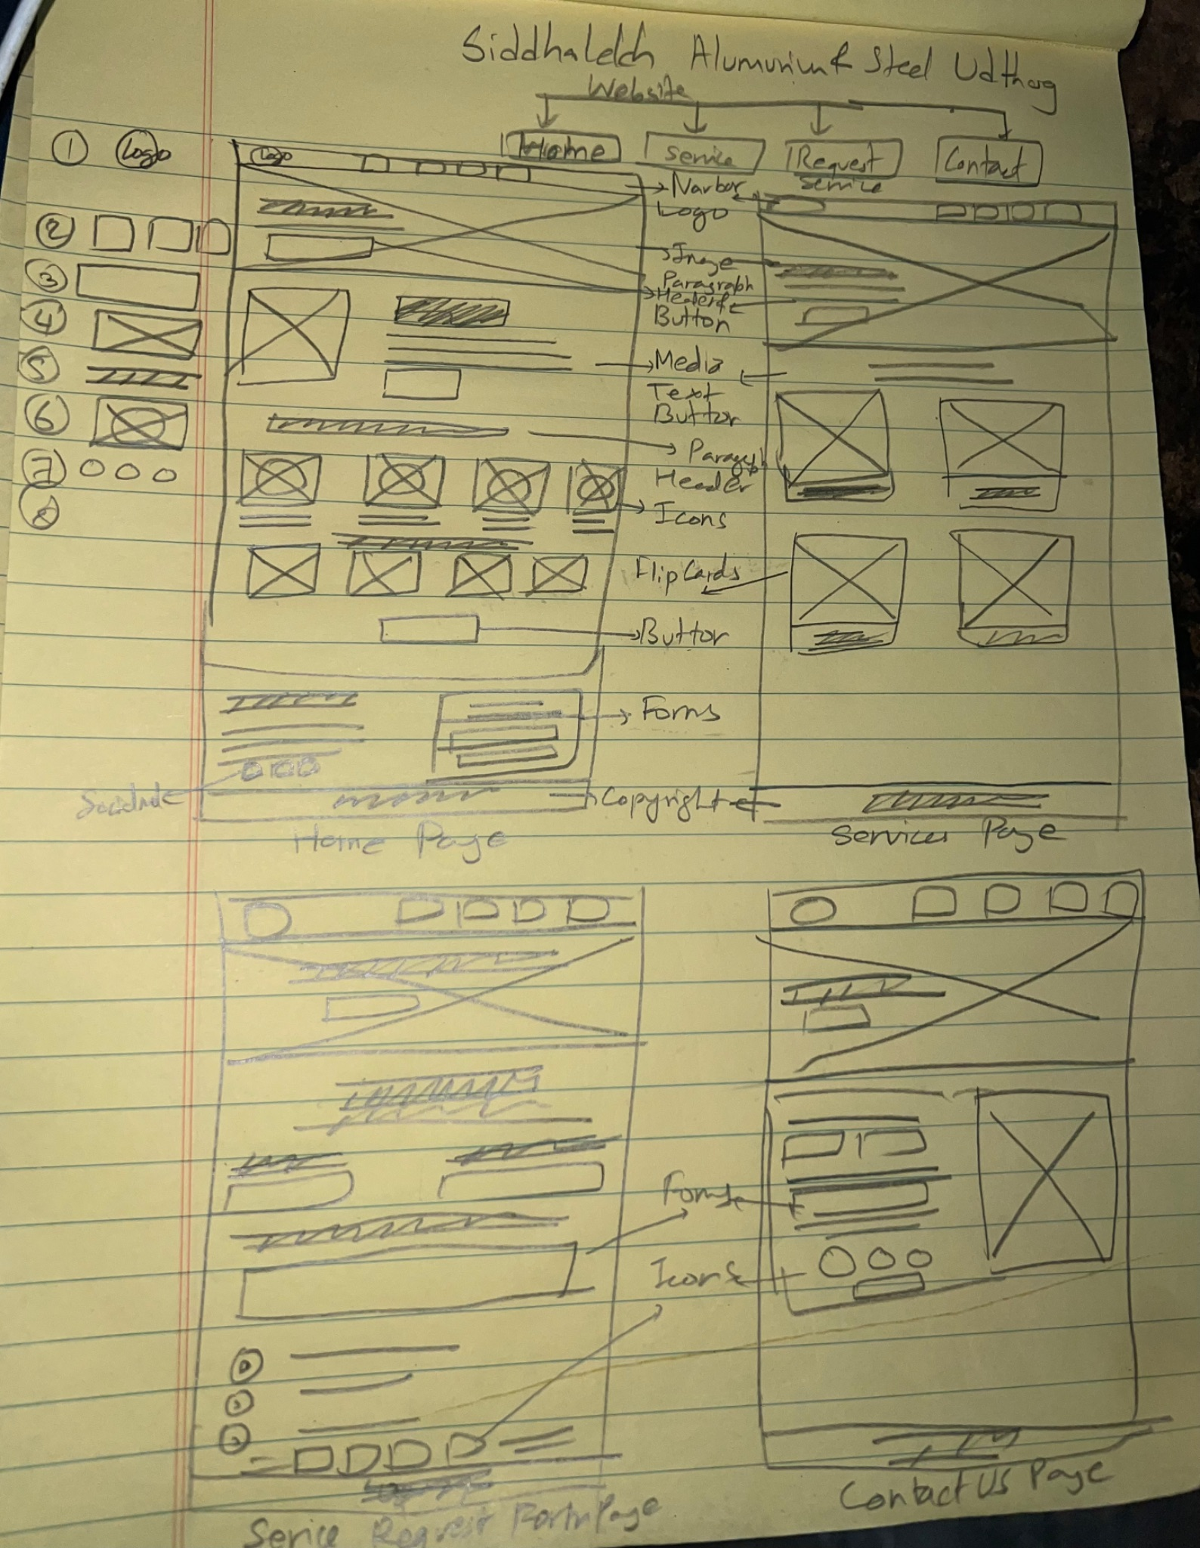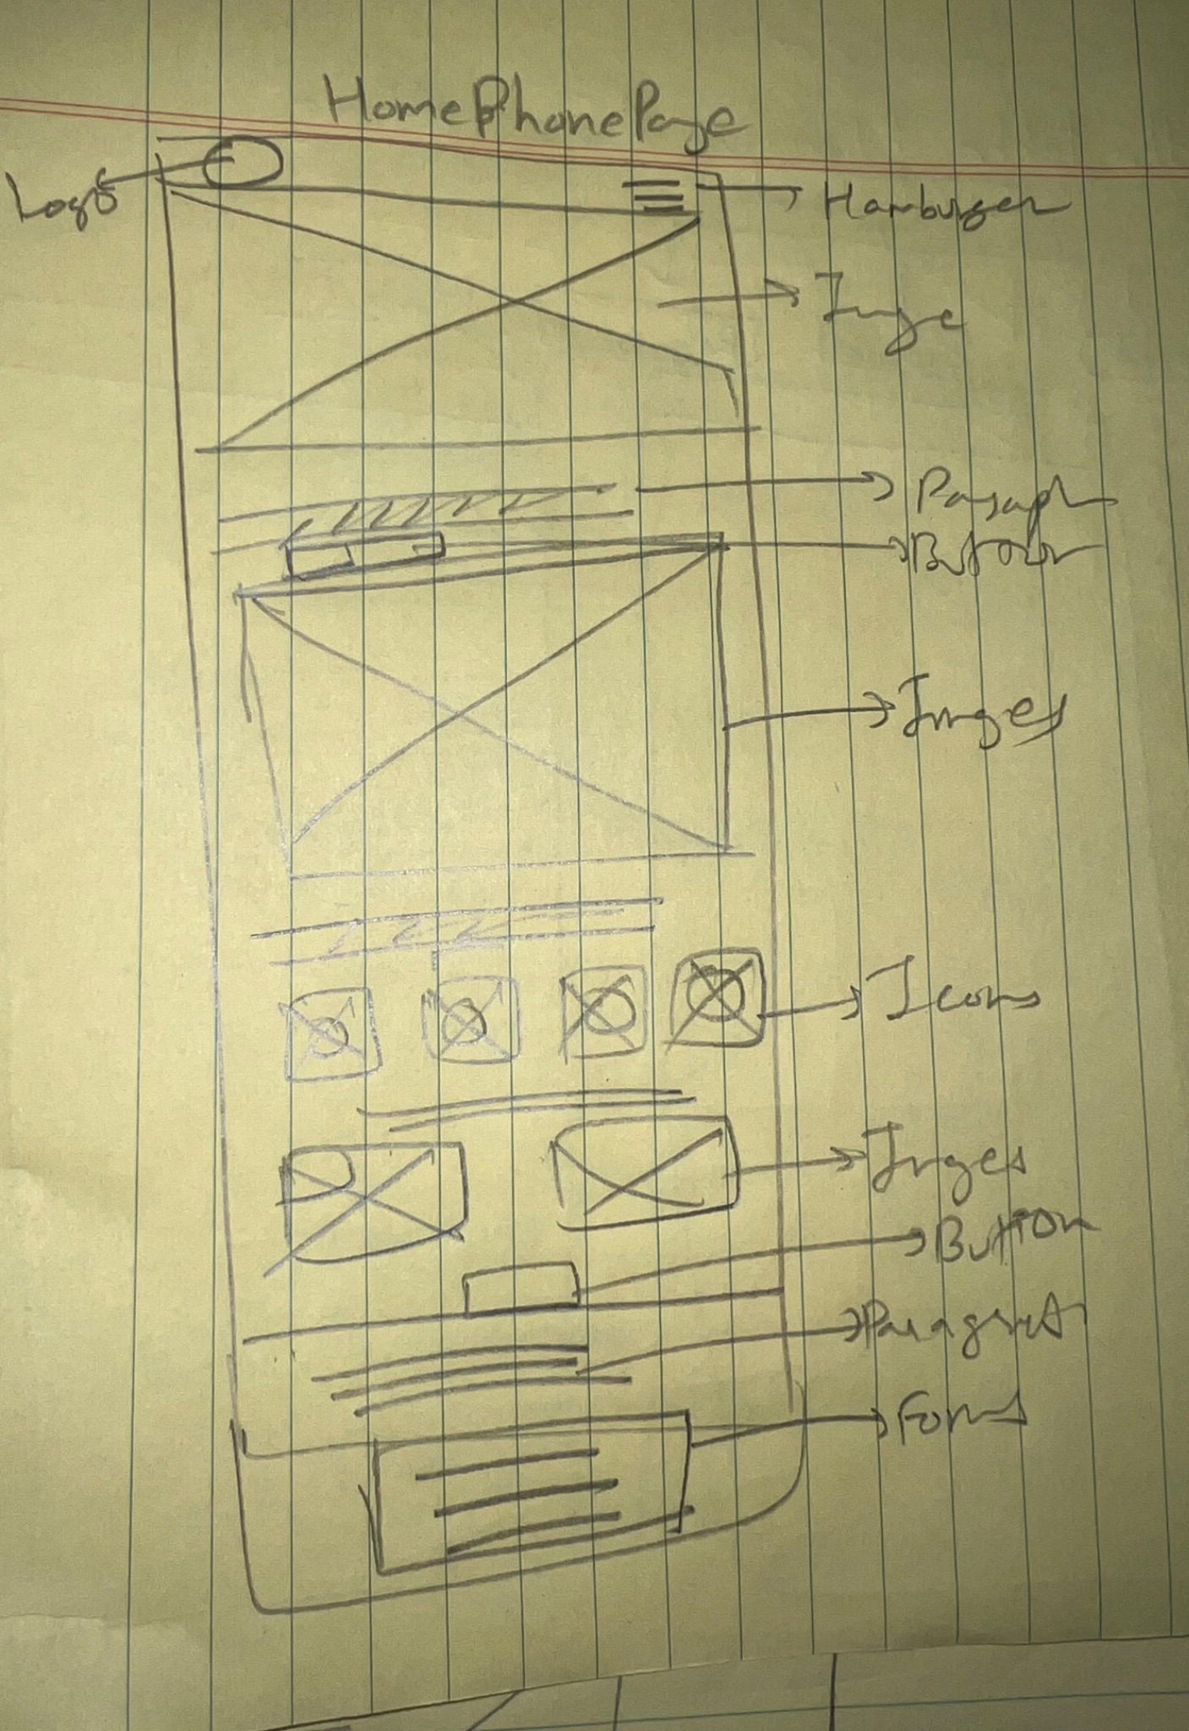

All Screen Mobile Screen(home page)
Sketch Rough Draft
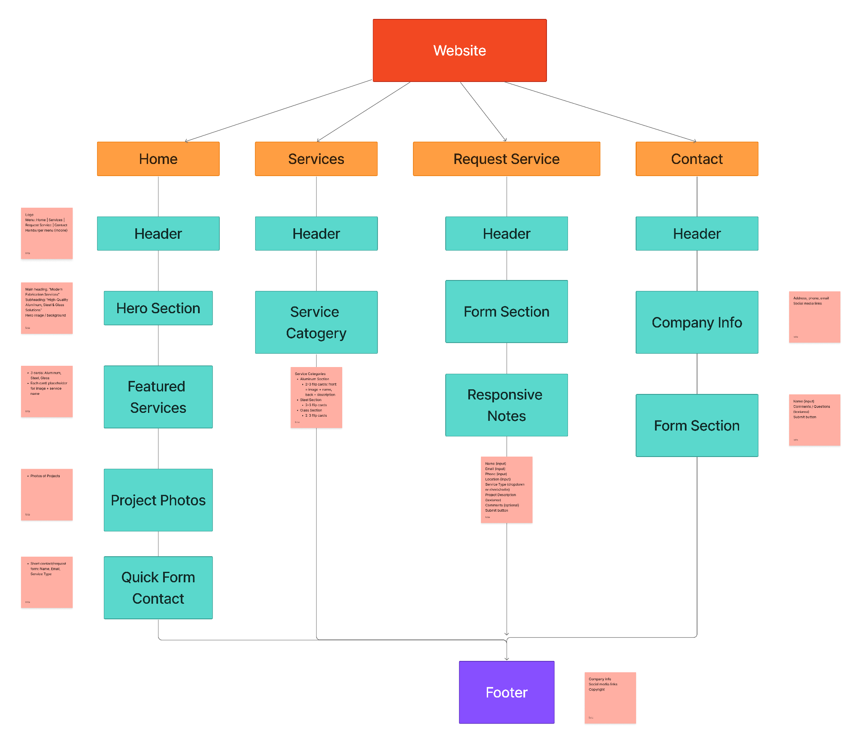Wireframe Flow

The Use:

Web Design Tenet | Implementation
GitHub and GitHub Pages | Project will be organized in a GitHub repo:  /images folder for service images  /css folder for main CSS  /less folder for Less variables and mixins  /index.html, /services.html, /request-service.html, /contact.html  Site published with GitHub Pages
Flexbox, and how to use Flexbox to present information effectively | Landing page uses Flexbox to align featured service cards in a row (column on mobile)  Services page uses Flex containers for flip cards in Aluminum, Steel, and Glass categories  Request Service form uses Flexbox for responsive layout of input fields and buttons  Ensures consistent spacing, alignment, and layout across all pages
Using advanced CSS selectors (at least 10 examples) | Descendant selector: .services .card p { font-size: 14px; }  Child selector: .services > .card { margin: 10px; }  Pseudo-class hover: .flip-card:hover { transform: rotateY(180deg); }  nth-child: .services .card:nth-child(odd) { background: #f0f0f0; }  Attribute selector: input[type="text"] { border: 1px solid #ccc; }  - Grouping: .card, .form-input { margin-bottom: 15px; }  ID: #request-form { width: 100%; }  Combinator: .services + .contact { margin-top: 50px; }  Pseudo-element: .card::after { content: ""; display: block; }  Class selector: .flip-card { perspective: 1000px; }
Interactive flip-cards in a Flex container | Services page uses flip cards for Aluminum, Steel, and Glass categories  Front shows image + service name  Back shows short description, benefits, and material info
Forms | Request Service page includes Name, Email, Phone, Location, Service Type dropdown (Aluminum/Steel/Glass), Project Description, Comments  Form styled using Less variables  Submit button includes hover effect  Form layout responsive on mobile using Flexbox
Visual techniques and responsiveness, including favicons, Font Awesome, Hamburger Menu implementation | Favicon represents company brand  Color palette: Aluminum silver, Charcoal gray, Glass blue, White  Font Awesome icons for service categories  Hamburger menu implemented for mobile  Responsive images, cards, and forms using media queries
The Less CSS Pre-processor | Colors, font sizes, spacing, and card dimensions stored as variables  Mixins for reusable Flexbox settings  Request Service form uses Less variables for input fields, button styling, and spacing  Easier maintenance and consistent styling across the website

